Module 7) JQuery Basic, Effects & Advanced

# 1• What is jQuery?

Ans: jQuery is a small, light-weight and fast JavaScript library. It is cross-platform and supports different types of browsers. It is also referred as ?write less do more? because it takes a lot of common tasks that requires many lines of JavaScript code to accomplish, and binds them into methods that can be called with a single line of code whenever needed. It is also very useful to simplify a lot of the complicated things from JavaScript, like AJAX calls and DOM manipulation.

# 2• How to Apply CSS Using JQuery, How to Add Class and Remove Class in Jquery, JQuery Animation?

Ans:

Add Class and Remove Class

Given an HTML element and the task is to add and remove multiple classes from it using JQuery

First select the element to which multiple classes will be added.

Then use [addClass() method](https://www.geeksforgeeks.org/jquery-addclass-with-examples/" \t "_blank) to add multiple classes to the element and removeClass() method to remove multiple classes. 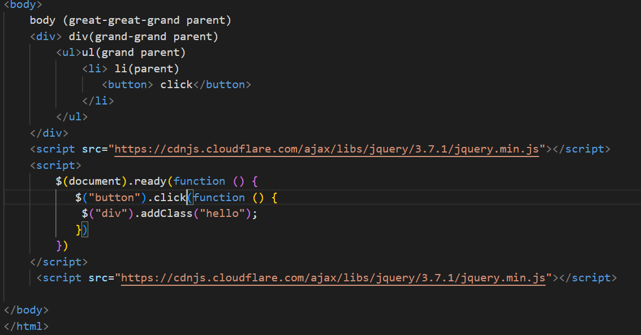

How to Apply CSS Using JQuery

By clicking the button, it adds multiple [CSS properties](https://www.geeksforgeeks.org/css-properties-complete-reference/) to the selected element, but by double-clicking the button, it adds only one CSS property. The motive of this example is to show the use of two types of CSS methods which are discussed.

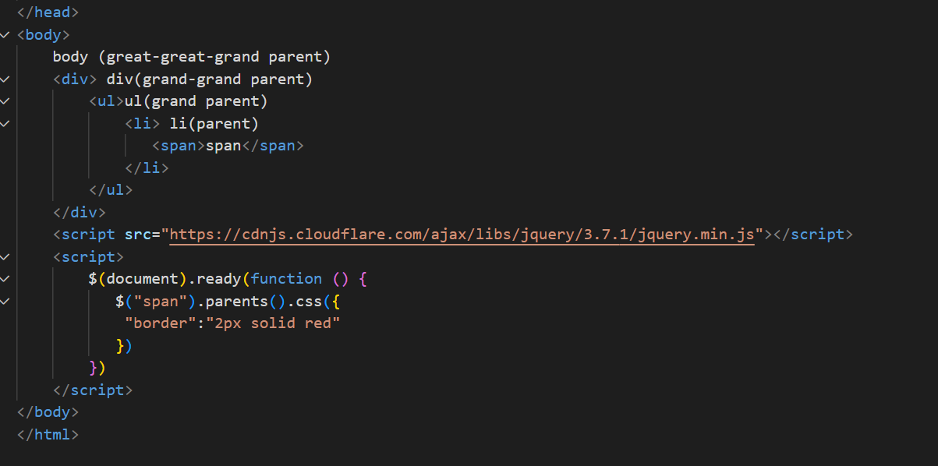

JQuery Animation

The jQuery animate() method provides you a way to create custom animations.

Syntax:

$(selector).animate({params}, speed, callback);

Here, params parameter defines the CSS properties to be animated.

The speed parameter is optional and specifies the duration of the effect. It can be set as "slow" , "fast" or milliseconds.

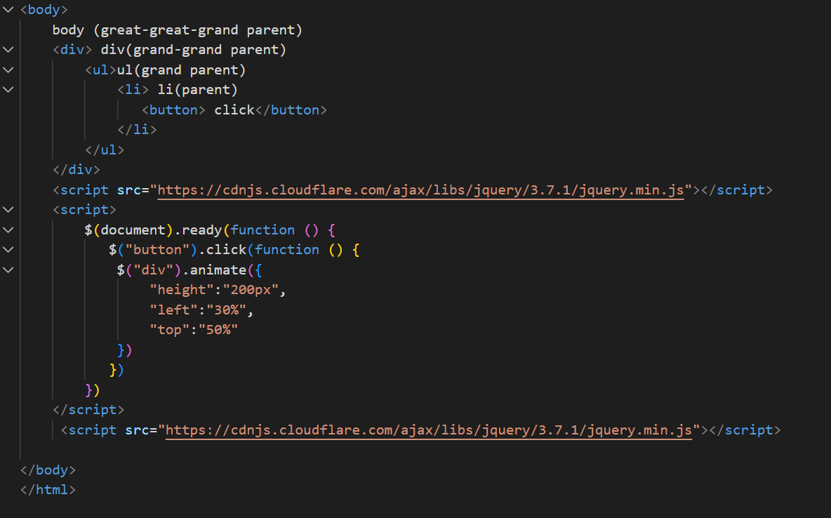

# 3 • How to create slider with animation?

Ans:slideUp():This method makes the element to slide up.  
Syntax:

$(selector).slideUp(speed,callback);

In this example, we show the slide up effect .If the Slide Up panel is clicked ,the corresponding change is made to the HTML element.